Ordnance Factory
Proposal:
- Pick
- Place
- Rotate
AUTOMATION SOLUTION-DIVISION
Pick & Place (Manipulator)

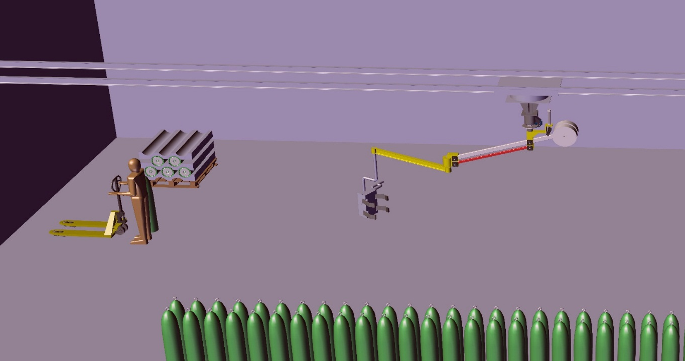

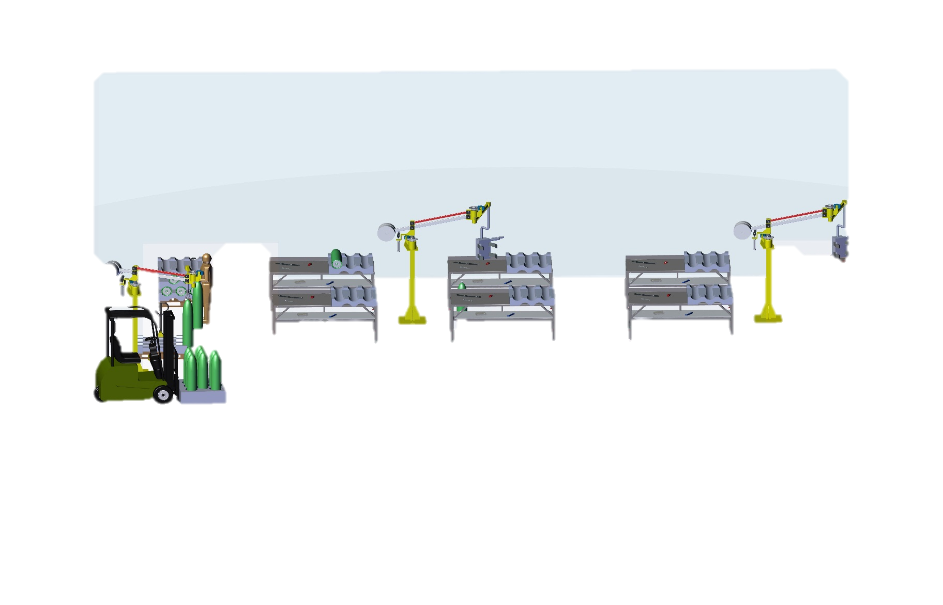

M/s, Ordnance Factory
Dehuroad, Pune-412101

Kind Attn: Mr.Sanjay Tambole

Dear Sir,

Thank you for giving us an opportunity to participate with our offer on the above project. We enclose herewith our proposal which includes:

- Requirement
- Scope of Works
- Pricing
- Technical Specification
- Terms & conditions

A. Requirement
- Energy efficient Design: The Pick & Place system should be energy efficient. The design shall ensure minimum possible power.
- Reduced Manpower: All heavy work will be done by manipulator so this system will require minimum labour work.
- Section ‘A’ will have one manipulator & gripper assembly with railing system along with tilting mechanics of gripper to complete pick & place operation of cylinder.
- Section ‘B’ will have total 3 manipulator or pick & place machines. 1st pick & place require at door place to pick cylinders from BOPT with a hook & to place it on manual stacker. Another two pick & place will require inside in a unit to complete process work. These two manipulators will handle their work without a rail system.

B.SCOPE OF WORKS:

The scope of work shall be exclusively on Pick & Place System. This includes picking of cylinder & placing it to desired location, tilting of cylinders up to 90- 180 degrees.

For the above scope, following set of activities are expected to be performed:

1. Design and development of pick & place system.
2. Development of site drawings for pick & place.
3.proposal for procurement, installation and commissioning of Pick & Place System with break up.
4. Project implementation plan.

Drawings

We will issue a full set of shop drawings for approval within 2 weeks of receiving the confirmed order and finalized design details.

Training

After installation of the automation system, we will train the Clients personnel in the operation and basic maintenance, including the understanding of the error codes on the control system (if applicable).

Warranty

The warranty period is twelve months from the date of installation and commissioning.

If a defect arises within the warranty period stated, which is attributable to faulty design, materials or installation workmanship the product will be repaired at our discretion without charge. This guarantee is subject to proper use of the product and assumes that the product is regularly serviced and maintained by skilled personnel in accordance with the operation and maintenance instructions supplied.

Maintenance and Service Agreement

We would suggest that you take advantage of a maintenance and service agreement on the Nihva products, which will guarantee trouble free operation and speed of response in an emergency. Customized proposals are available on request.

C.PRICING

Section 171 – Pick & Place Machine

SrNo | Description | Quantity | Price in  INR/Each | Total Amount  In INR
1. | Manipulator | 1 | 684000 | 6,84,000
2. | Installation Charges for above manipulator | 1 | 20000 | 20,000
3. | Gripper | 1 | 475000 | 4,75,000
4. | Installation Charges for above Gripper | 1 | 10000 | 10,000
5. | Railing System 20 Meters | 1 | 520000 | 5,20,000
6. | Installation Charges for above Railing | 1 | 20000 | 20,000
7. | Total Amount for Section A-171 |  |  | 17,29,000

D 1. Technical Specifications:

1 | Manipulator
a> Manipulator: 6 Bar
b> Capacity: 150 kg
c> Mounting: Rail Mounted
d> Reach arm: 3 meter
2 | Gripper
Clamper Expansion
Max.: 450mm
Min.: 100mm
Min Height: 350mm
Max. Height: 1650mm
Rotation: 180 & 90 Degree
3 | Rail System
 | Length of Rail: 20 meter

Section 166 – Pick & Place Machine

SrNo | Description | Quantity | Price in  INR/Each | Total Amount  In INR
1. | Manipulator near Door | 1 | 684000 | 6,84,000
2. | Installation Charges for above manipulator | 1 | 20000 | 20,000
3. | Manipulator | 2 | 684000 | 1,36,8000
4. | Installation Charges for above Manipulator | 2 | 20000 | 40,000
5. | Gripper | 2 | 475000 | 9,50,000
6. | Installation Charges for above Gripper | 2 | 10000 | 20,000
 | Total Amount for Section B-166 |  |  | 30,82,000

D 2.Technical Specifications:

1 | Manipulator
a> Manipulator: 6 Bar
b> Capacity: 150 kg
c> Mounting: Floor mounted
d> Reach arm: 3 meter
2 | Gripper
Clamper Expansion
Max.: 450mm
Min.: 100mm
Min Height: 350mm
Max. Height: 1650mm
Rotation: 180 & 90 Degree

E. Terms and Conditions:
- Price: Ex. Works Pune
- P & F Charges: @ 3% of Total supply value.
- Freight Notes: Extra as applicable
- Delivery: within 9-10 weeks from the date of receipt of confirmed purchase order, Advance Payment, Drawing approval.
- Payment :80% Advance along with Confirmed Purchase Order & Balance before dispatch.
- Insurance: Extra as applicable.
- Sales Tax: Extra as applicable at the time of dispatch. Presently @ 13.5% VAT (Supply within Maharashtra) OR @ 2% CST against form "C" (Outside Maharashtra)
- Service Tax: Extra @ 15%
- Validity :15 days from the date of quotation.
- Warranty :12 Months from the date of supply.

Note: - The implementation of “IGST Act and CGST Act along with SGST Act and UTGST ACT” will be enforced as per notified date, accordingly IGST and CGST along with SGST and UTGST will be applicable at prescribed rates and accordingly these taxes will be charged extra.

Please feel free to Contact Mr. Mayur Derle on 7709209333 For any further Clarification in this Concern.

With Best Regards
Pooja Badre
7709586333
For NIHVA Technologies Pvt Ltd

